**COMPUTER NETWORKS LAB ( 5TH SEM C3 BATCH)**

**PROGRAM 1-**

Construct topology and simulate sending a simple PDU from source to destination using Hub and Switch accordingly.

USING HUB

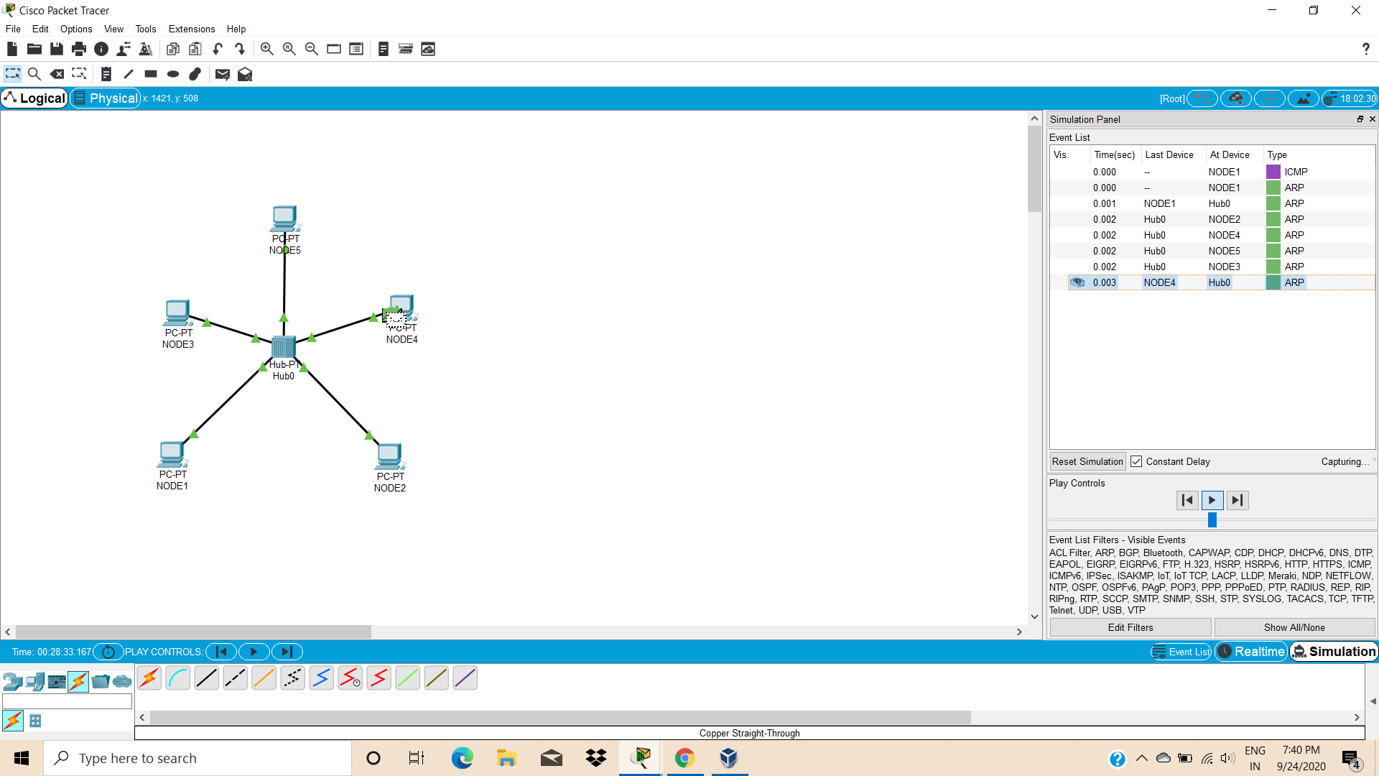

Topology with 5 nodes connected to Hub.

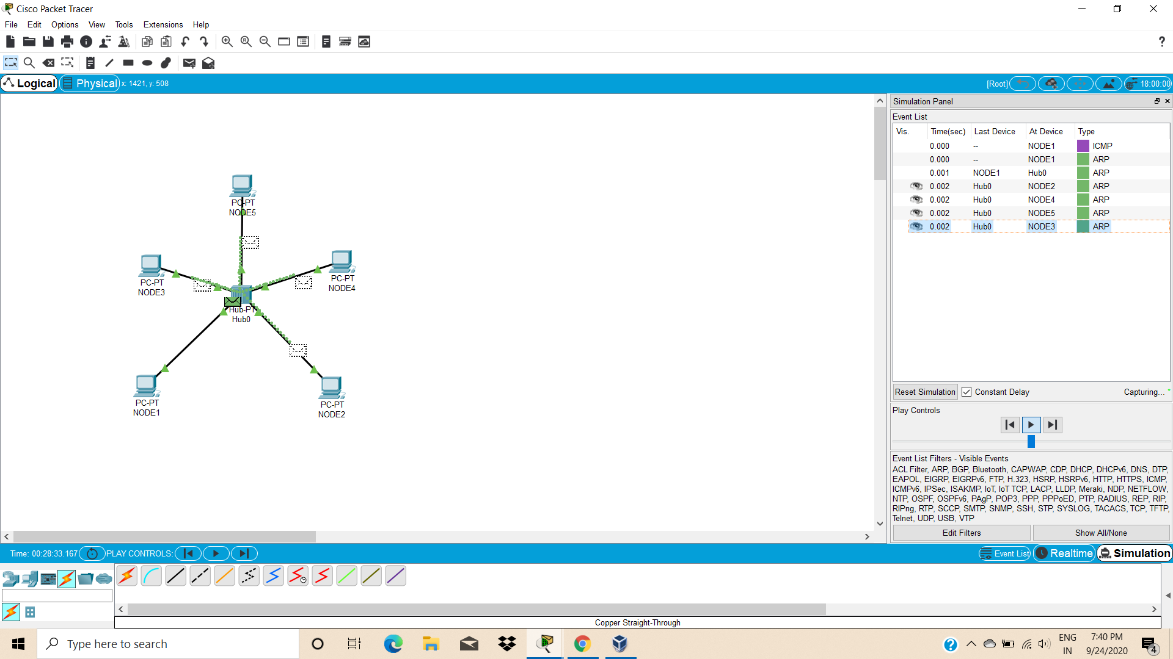

Hub broadcasting the PDU packet(data) to all the nodes connected.

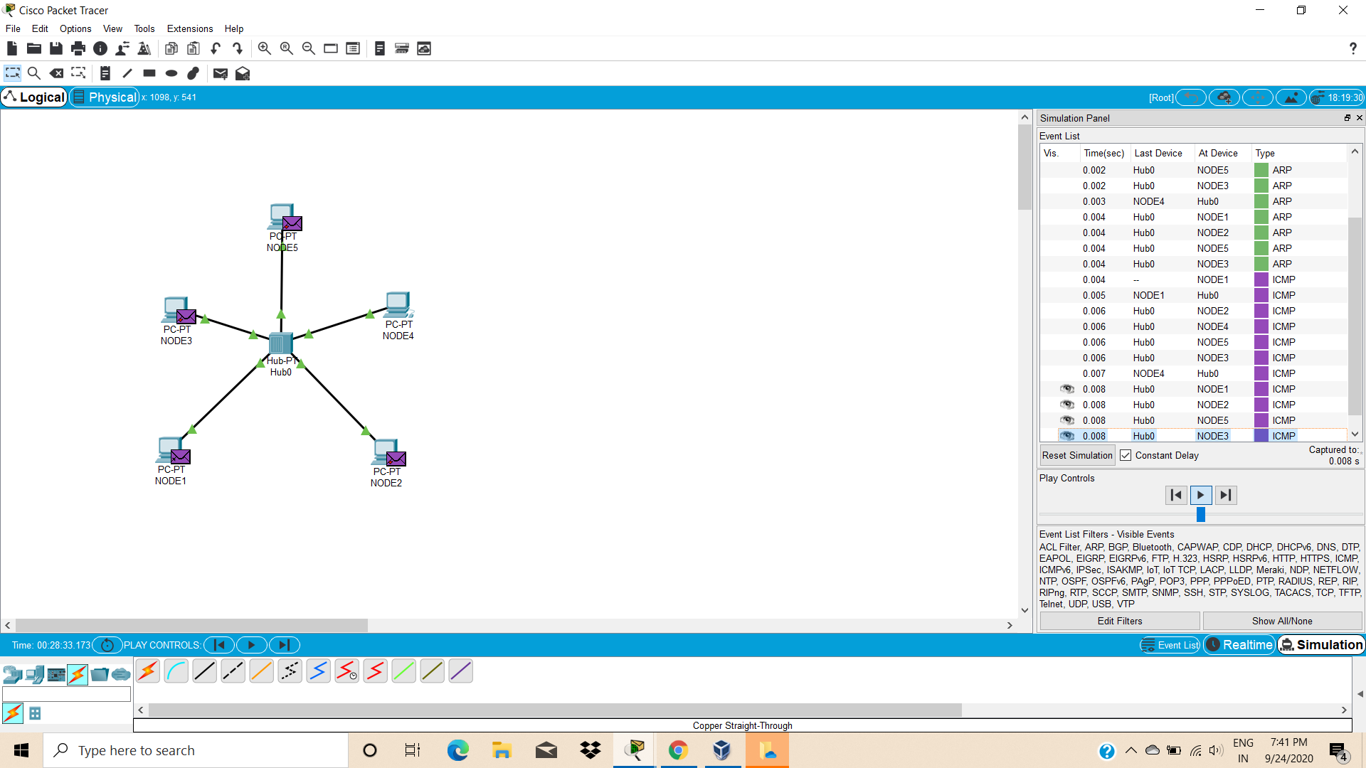

Receiver sending acknowledgement to all the nodes, but this is accepted by the sender only.

USING SWITCH

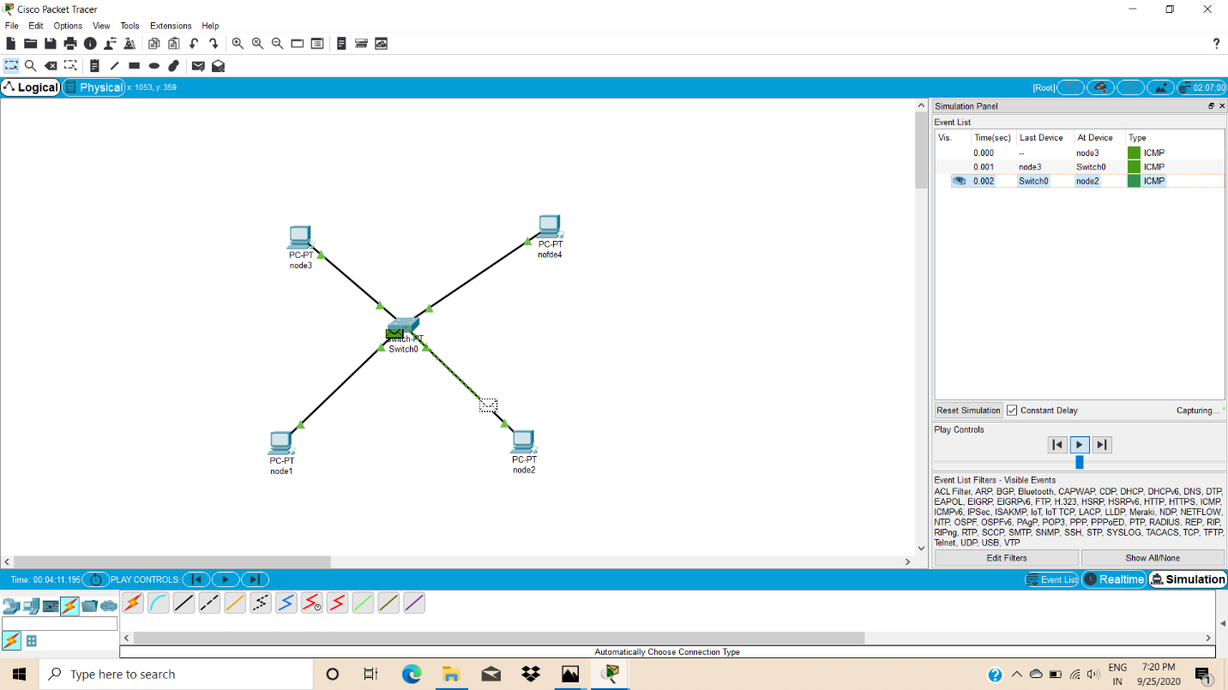

Switch forwards the packet to the receiver node only.

Observation from the program 1:

* Difference between the function of hub and switch.
* Hub broadcasts but switch forwards
* How to set the IP address to each of the pc
* Adding the ports to the switch.
* Simulating the network created using hub and switch.